**Team ID : PNT2022TMID34251**

**Team Members : Jenifa.J , Annal Lici.A , Nisanthini.M , Pavithra.S**

**FOREST FIRE DETECTION**

**1.INTRODUCTION**

**1.1. PROJECT OVERVIEW**

Forest is one of the major wealth of our country. Forests provide enormous material goods and environmental services. They are useful for industry as well as rural economic growth. Forests provide timber, resins, rubber, food items, medicines etc. Forests also provide best environmental service to the world. The trees in the forests produce oxygen by photosynthesis, which reduces global warming. Forests absorb carbon dioxide which is a raw material for photosynthesis. Forests prevents soil erosion, absorb toxic gases. Forests are the homes for wild animals. At the same time, when the forest is under fire it emits lot of carbon dioxide leads to climate change and global warming. So the forest fire has to be detected at earlier stage. Due to isolation, inaccessibility, tough weather, shortage of frontier staff, the early finding of forest fire is a difficult task. Nowadays, the vision based fire detection method replaces the conventional fire detection methods. The digital camera and content based video processing technologies are used to implement the vision based fire detection. The characteristic feature like fire, motion and geometry are used in vision based fire detection systems.

**1.2 PURPOSE**

Nowadays, the vision based fire detection technique is used widely to detect fires. Along with the surveillance systems the vision based fire detection technique can be incorporated at relatively low additional cost. The advantages of vision based fire detection techniques are listed here:i) the fast response to fires. ii) the location of fire is sensed using this method not just the radiation, iii) the captured images can be analyzed and it can be used for future purposes and storage, iv) it can be used for outdoor places which covers large area.

**2. LITERATURE SURVEY**

**2.1 EXISTING PROBLEM**

Existing systems uses electronic sensors to detect fire or smoke. The change in temperature indicates the presence of fire or smoke in a region which can be detected by the sensors using radiation heat. As forests are in a remote location, installation and maintenance of sensors over large area is difficult. So the sensors cannot be used to deploy over large area such as forests, petrochemical plant, and saw mills etc. The other consequence is, the sensor would detect heat or smoke only when it reaches nearer. One of the main causes of destruction of archaeological and cultural heritage sites, especially in the Mediterranean region, is wildfires. These sites, treasured and tended for long periods of time, are usually surrounded by old and valuable vegetation or situated close to forest regions. The increase in seasonal temperatures has caused an explosion in the number of self-ignited fires in forested areas, which fanned by winds and fuelled by dry vegetation become disastrous. Extreme weather conditions such as storms or floods also pose greats risk for these sites. Beyond taking precautionary measures to avoid forest fires, early warning and immediate response to a fire break out is the only way to avoid human losses and environmental and cultural heritage damage. Although several technologies based on different sensors have been proposed for wildfire surveillance, the majority of existing fire detection systems does not realize the full potential of stateof-the-art technologies due to the lack of an integrated approach.

**2.2 REFERENCES**

|  |  |  |  |
| --- | --- | --- | --- |
| **Author** | **Title** | **Source** | **Findings** |
| [Letricia P.S. Avalhais](https://ieeexplore.ieee.org/author/37085740823) et al. (2016) | 'Fire detection on unconstrained videos using color-aware spatial modeling and motion flow | [IEEE 28th International Conference on Tools with Artificial Intelligence](https://ieeexplore.ieee.org/xpl/conhome/7811909/proceeding) | In this work, the focused semantic event is the presence of fire in videos. |
| [Haoran Zhu](https://www.researchgate.net/profile/Haoran-Zhu-6) et al. (2019) | A perceptron algorithm for forest fire prediction based on wireless sensor networks | Journal on Internet of Things | This paper presents a description and analysis of a forest fire prediction methods based on machine learning, which adopts WSN (Wireless Sensor Networks) technology and perceptron algorithms to provide a reliable and rapid detection of potential forest fire. |
| Adnan et al. (2018) | Forest fire detection using lora wireless mesh topology. | [2nd East Indonesia Conference on Computer and Information Technology](https://ieeexplore.ieee.org/xpl/conhome/8869568/proceeding) | This paper designed forest fire detectors that use LoRa mesh network. The detector is able to inform us where the fire location using Google map. |
| [RobertTobera](https://www.sciencedirect.com/science/article/pii/S1877705812032201" \l "!) et al. (2015) | Early Forest Fire Detection and Verification using Optical Smoke, Gas and Microwave Sensors | [Procedia Engineering](https://www.sciencedirect.com/journal/procedia-engineering) | An integrated approach for early forest fire detection and suppression is based on an adequate combination of different detection systems depending on wildfire risk, the size of the area and human presence affiliated with an adequate logistical infrastructure, training by simulation, and innovative extinguishing technology. |
| [Smriety Regmi](https://link.springer.com/chapter/10.1007/978-3-030-73569-2_8#auth-Smriety-Regmi) et al. | Forest Fire Detection and Monitoring | [Earth Observation Science and Applications for Risk Reduction and Enhanced Resilience in Hindu Kush Himalaya Region](https://link.springer.com/book/10.1007/978-3-030-73569-2) | Forest fire not only causes ecological, economic, and material damages but also destroys the forests which are an irreplaceable sink of carbon. In order to support foresters, government authorities, and firefighters in developing efficient fire-risk management plans and to properly monitor and identify the risk areas, |

**2.3.PROBLEM STATEMENT DEFINITION**

* In the past, fires were detected by watching towers or using satellite images.
* Satellites collect images of fires and send them to a monitoring authority for review.
* If the images appear to show a fire, the authority will determine whether or not the fire is burning.
* But this approach was slow because the fire may have spread in the large areas and caused a lot of damage before the rescue team arrived.
* With the watchtower method, there was always a man on the tower who monitored the area and informed when there was a fire.
* This method was slow because it required a man to be present in the forest before the fire could spread, and it always takes time for this type of wildfire to develop.
* Since it's impossible to place a man in every part of a forest, it's important to have monitoring devices in certain areas so we can keep an eye on the forest.
* Both watching towers and satellite images failed to detect the presence of a fire early on, which resulted in more damage being done by the fire.
* When using computer vision for fires, there are concerns about probability. AI machines trained on human-supplied data can only recognize predictable fires, their severity, and their trajectories, but nature is not so simple. In fact, it's not even close to what we expected, given that detectable fires account for only 10% of actual wildfires worldwide.
* Fortunately, fire behavior in urban environments, especially in wildlife environments, is still poorly predictable.
* Track recurring patterns to draw conclusions, even if you can't estimate the exact probability of wildfires occurring in a particular area.
* Predictive analytics based on these insights are becoming increasingly effective in detecting, mitigating and preventing fires

**3.IDEATION & PROPOSED SOLUTION**

**3.1.EMPATHY MAP CANVAS**

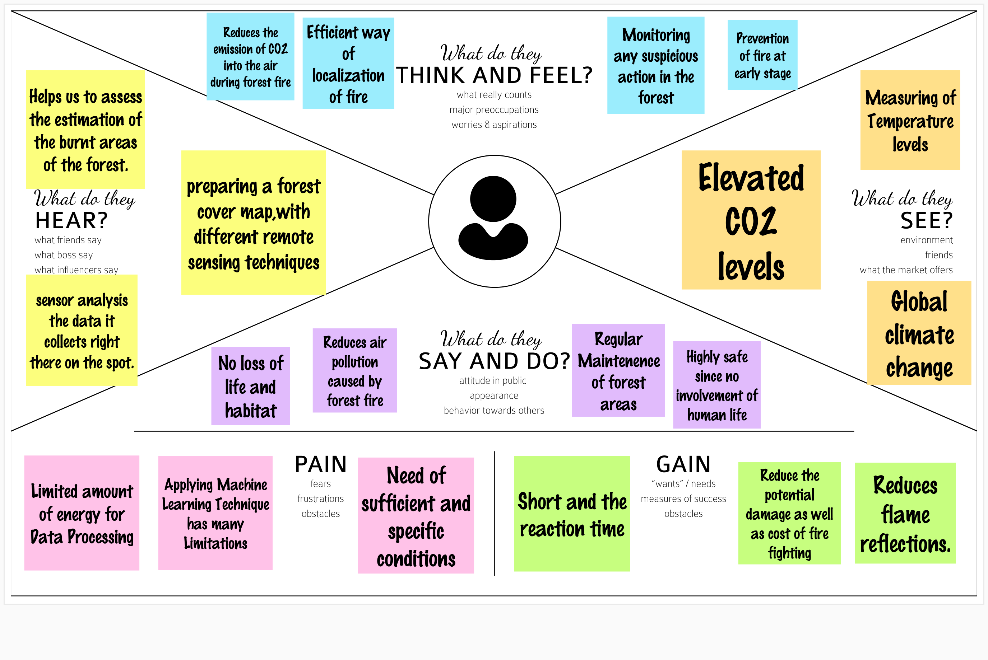

**3.2.IDEATION & BRAINSTORMING**

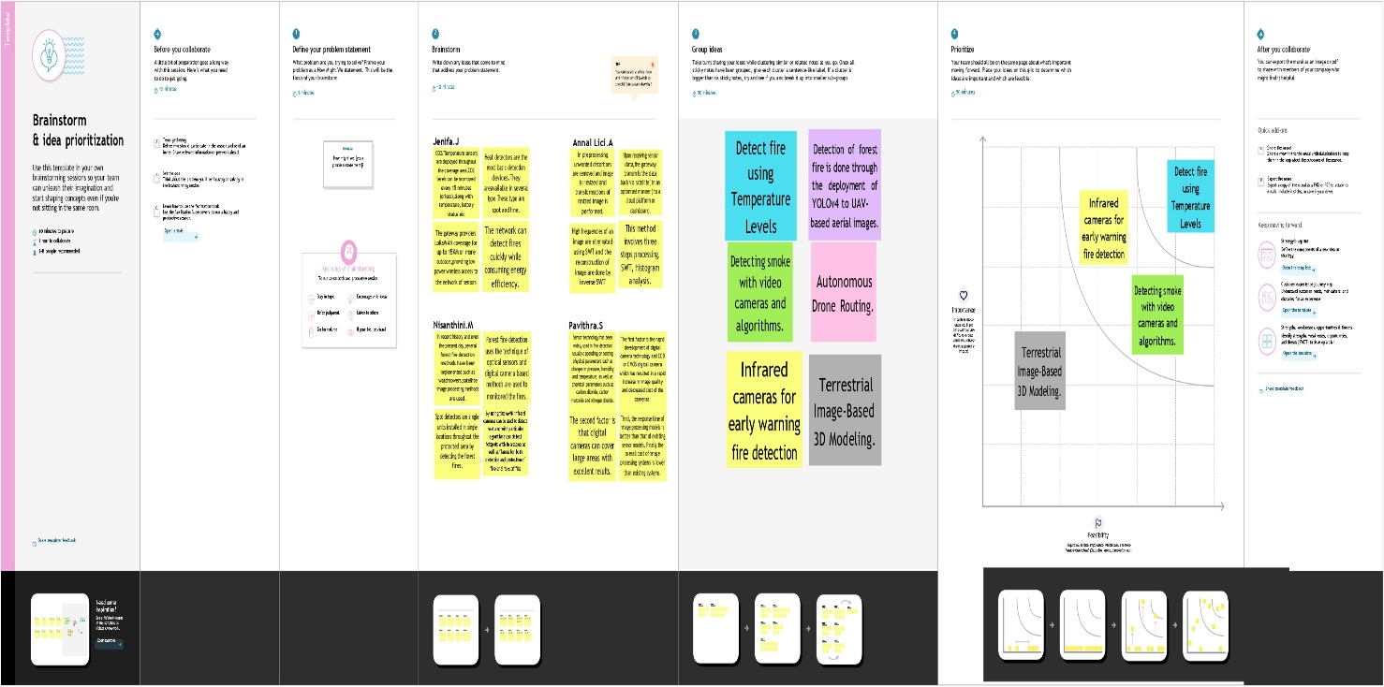

**3.3.PROPOSED SOLUTION**

|  |  |  |
| --- | --- | --- |
| **S.NO** | **PARAMETER** | **DESCRIPTION** |
| 1. | Problem Statement (Problem to be solved) | Over the last few decades, forest fires are increased due to deforestation and global warming. Many trees and animals in the forest are affected by forest fires. Technology can be efficiently utilized to solve this problem. Forest fire detection is inevitable for forest fire management. |
| 2 | Idea/Solution description | Modern fire protection systems are comprised of three main components— fire detection, alarms and notifications, and suppression, all of which must function together to provide the necessary fire protection for a given building. Designing a fire alarm and notification system requires an integrated approach that includes a comprehensive analysis of the entire fire protection system. This analysis is necessary to gain a thorough understanding of how all the main components of the overall fire protection system will work together. This analysis needs to be conducted before the system is installed. |
| 3 | Novelty/Uniqueness | The novelty of system is real-time monitoring, early prediction, validation through UAV and fire confirmation using image processing. The proposed system presents higher true fire detection rate of about 95-98 percent. |
| 4 | Social Impact  /Customer  Satisfaction | Timely information about the appearance of fire reduce the number of areas affected by this fire and thereby minimizes the costs of fire extinguishing and the damage caused in the woods. Monitoring of the potential risk areas and an early detection of fire can significantly shorten the reaction time and also reduce the potential damage caused by the forest fire. |
| 5 | Business Model( Revenue Model) | Aspirating smoke detectors continuously sample air to provide early warnings of fire hazards, helping detect threats before they escalate. Some devices provide multi-level warnings and are equipped with wide-  Ranging sensitivity to identify even the most negligible amounts of smoke, helping to prevent smalls fire from taking hold and causing wide spread damage.  Unlike traditional detection technology – which is largely passive, waiting for smoke to reach sensors – aspirating devices are designed to sample and test air near the most likely sources of fires throughout a building. Aspirating smoke devices can be positioned in hard-to-monitor places, such as ceilings, air grilles and openings, or within critical spaces, including  Operating and patient rooms. Early detection technologies can also draw air from targeted locations back to a central system that continuously monitors for trace amounts of smoke. |
| 6 | Scalability of the Solution | Changes in the use or occupancy of a building can result in compliance issues and a  fire alarm system that no longer provides sufficient protection. If future changes are anticipated, fire safety engineers can design a fire alarm system with this in mind, providing  a flexible infrastructure that includes the proper wire size and additional circuits distributed in a way that accommodates future growth and change.  Perhaps one of the most compelling reasons to design a fire alarm system that goes above and beyond  The minimum requirements from the start is the fact that fire codes and other applicable regulations can and do change. And, changes that are made retroactively can trigger  Potentially very expensive alterations in a fire  Alarm system. This is also why it is so important to work with highly qualified fire safety engineers who can anticipate coming changes and proactively design your system to meet new requirements. |

**3.4 PROBLEM SOLUTION FIT**

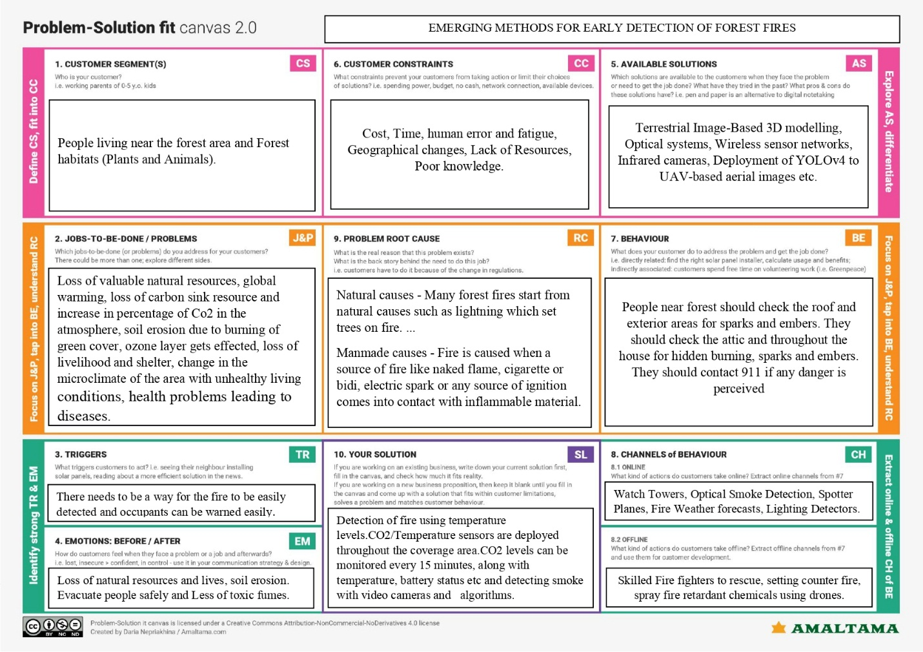

**4. REQUIREMENT ANALYSIS**

**4.1 FUNCTIONAL REQUIREMENTS**

|  |  |  |
| --- | --- | --- |
| **FR No.** | **Functional Requirement (Epic)** | **Sub Requirement (Story / Sub-Task)** |
| FR-1 | Video surveillance start | Start surveillance through remote control |
| FR-2 | Forest monitoring | Continuous monitoring through camera |
| FR-3 | Detect fire | Fire is detected through CNNmodel |
| FR-4 | Alert | Alert the forest officials through message |

**4.2 NON-FUNCTIONAL REQUIREMENTS**

|  |  |  |
| --- | --- | --- |
| **FR No.** | **Non-Functional Requirement** | **Description** |
| NFR-1 | Reliability | Model is safe to install |
| NFR-2 | Security | More secure environment |
| NFR-3 | Availability | Build model is available all the time |
| NFR-4 | Performance | Model will achieve high accuracy |

**5. PROJECT DESIGN**

**5.1 DATA FLOW DIAGRAM**

DFD LEVEL0(Industry standard)

Collect the dataset in forest

Include information regarding temperature, humidity, wind and rain of that forest

Usage of algorithms for accuracy, prediction, recall, training and testing the dataset

Show the output (if forest fire occurs or not)

**5.2 SOLUTION & TECHNICAL ARCHITECTURE**

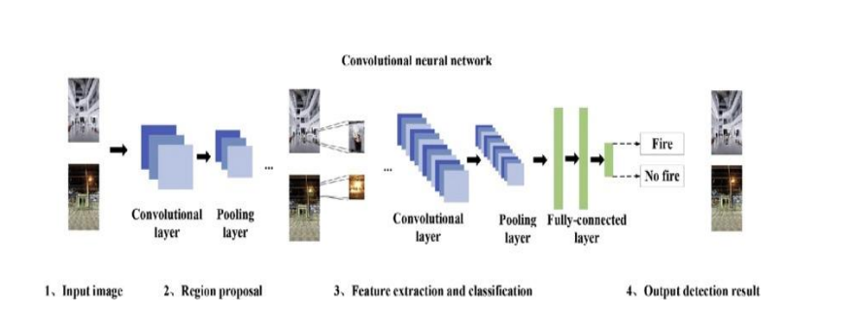

**5.3 USER STORIES**

|  |  |  |  |  |  |  |
| --- | --- | --- | --- | --- | --- | --- |
| **User Type** | **Functional**  **Requirement (Epic)** | **User Story Number** | **User Story / Task** | **Acceptance criteria** | **Priority** | **Release** |
| Environmentalist | Collect the data | USN-1 | As an Environmentalist,it is necessary to collect the data of the forest which includes  temperature,humidity,wind and rain of the forest | It is necessary to collect the right data else the prediction may become wrong | High | Sprint-1 |
|  |  | USN-2 | Identify algorithms that can be used for prediction | To collect the algorithm to identify the accuracy level of each algorithms | Medium | Sprint-2 |
|  |  | USN-3 | Identify the accuracy of each algorithms | Accuracy of each algorithm calculated so  That it is easy to obtain the most accurate output | High | Sprint-2 |
|  |  | USN-4 | Evaluate the Dataset | Data is evaluated before processing | Medium | Sprint-1 |
|  |  | USN-5 | Identify accuracy, precision, recall of each algorithms | These values  Are important for obtaining the right output | High | Sprint-3 |
|  |  | USN-6 | Outputs from each algorithm are obtained | It is highly used to predict the effect and to take precautionary measures. | High | Sprint-4 |

**6. PROJECT PLANNING & SHEDULING**

**6.1 SPRINT PLANNING AND ESTIMATION**

**Project Development Phase**

**Sprint 1**

**Project Design &Planning**

**Ideation Phase**

**Project Development Phase**

**Sprint 2**

**Project Design &Planning**

**Project Design Phase -1**

**Project Development Phase**

**Sprint 4**

**Project Design &Planning**

**Project planning Phase**

**Project Development Phase**

**Sprint 3**

**Project Design &Planning**

**Project Design Phase -2**

**6.2 SPRINT DELIVERY SCHEDULE**

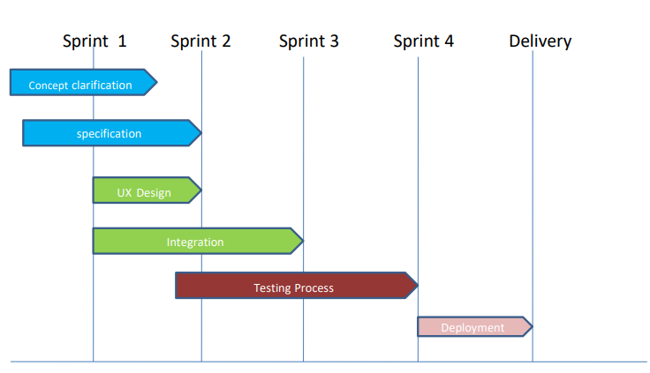

**7. CODING AND SOLUTIONING**

import cv2

import numpy as np

import smtplib

import playsound

import threading

Alarm_Status = False

Email_Status = False

Fire_Reported = 0

def play_alarm_sound_function():

while True:

playsound.playsound('alarm-sound.mp3',True)

def send_mail_function():

recipientEmail = "p.pavithra313@gmail.com"

recipientEmail = recipientEmail.lower()

try:

server = smtplib.SMTP('smtp.gmail.com', 587)

server.ehlo()

server.starttls()

server.login("servercloud56@gmail.com", 'ghgblctrqqgnniee')

server.sendmail('Fire detected', recipientEmail, "Warning A Fire Accident has been reported ")

print("sent to {}".format(recipientEmail))

server.close()

except Exception as e:

print(e)

video = cv2.VideoCapture("forest2.mp4") # If you want to use webcam use Index like 0,1.

while True:

(grabbed, frame) = video.read()

if not grabbed:

break

frame = cv2.resize(frame, (960, 540))

blur = cv2.GaussianBlur(frame, (21, 21), 0)

hsv = cv2.cvtColor(blur, cv2.COLOR_BGR2HSV)

lower = [18, 50, 50]

upper = [35, 255, 255]

lower = np.array(lower, dtype="uint8")

upper = np.array(upper, dtype="uint8")

mask = cv2.inRange(hsv, lower, upper)

output = cv2.bitwise_and(frame, hsv, mask=mask)

no_red = cv2.countNonZero(mask)

if int(no_red) > 15000:

Fire_Reported = Fire_Reported + 1

cv2.imshow("output", output)

if Fire_Reported >= 1:

if Alarm_Status == False:

threading.Thread(target=play_alarm_sound_function).start()

Alarm_Status = True

if Email_Status == False:

threading.Thread(target=send_mail_function).start()

Email_Status = True

if cv2.waitKey(1) & 0xFF == ord('q'):

break

send_mail_function()

cv2.destroyAllWindows()

video.release()

**8. TESTING**

**8.1 TEST CASE**

Object testing is to test object as individual components, which are often larger than single function. Here following activities have taken place.

* Testing the individual operations associated with object.
* Testing individual object classes.
* Testing cluster of objects.
* Testing object oriented systems.

Now we will discuss how testing and debugging is done of this application. Our application can be divided into parts like;

* To make queries to database and retrieve information from it.
* Reduce some memory requirements for the database.
* Maintain database so that unauthorized access can not affect.

The software engineering process can be viewed as a spiral. Initially system engineering defines the role of software and leads to software requirement analysis where the information domain, functions, behavior, performance, constraints and validation criteria for software are established. Moving inward along the spiral, we come to design and finally to coding. To develop computer software we spiral in along streamlines that decrease the level of abstraction on each turn.

A strategy for software testing may also be viewed in the context of the spiral. Unit testing begins at the vertex of the spiral and concentrates on each unit of the software as implemented in source code. Testing is progress by moving outward along the spiral to integration testing, where the focus is on the design and the construction of the software architecture. Talking another turn on outward on the spiral we encounter validation testing where requirements established as part of software requirements analysis are validated against the software that has been constructed. Finally we arrive at system testing, where the software and other system elements are tested as a whole.

**8.2.USER ACCEPTANCE TESTING**

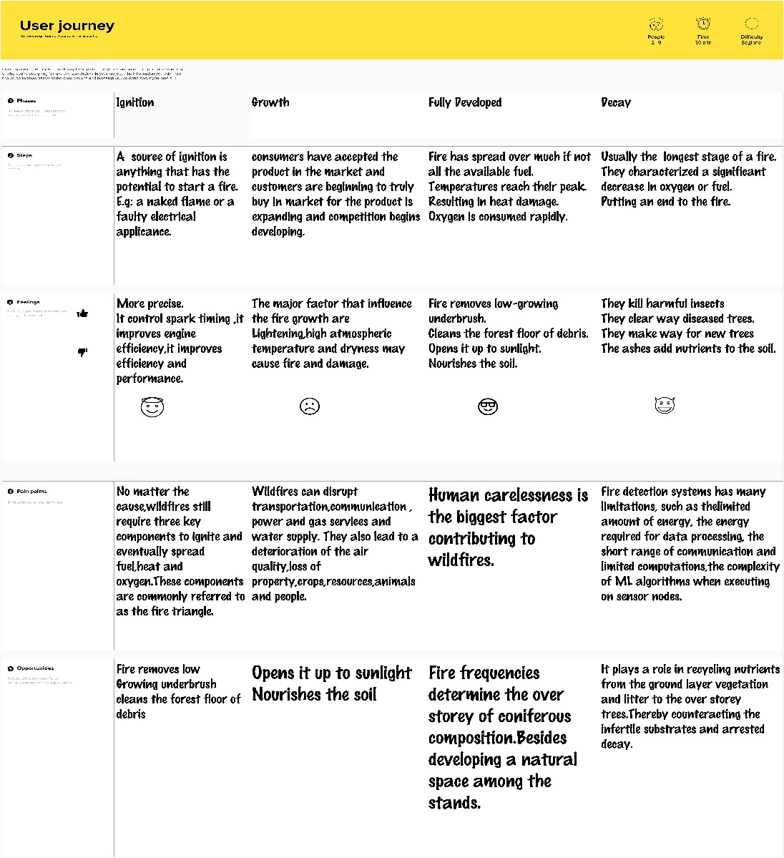

**9.RESULTS**

* Get the input image and discuss feature maps, learning the parameters of such maps, how patterns are detected, the layers of detection, and how the findings are mapped out.
* The second part of this step will involve the Rectified Linear Unit or ReLU. We will cover ReLU layers and explore how linearity functions in the context of Convolutional Neural Networks. Not necessary for understanding CNN's, but there's no harm in a quick lesson to improve your skills.
* In this part, we'll cover pooling and will get to understand exactly how it generally works. Our nexus here, however, will be a specific type of pooling; max pooling.
* Flattening: This will be a brief breakdown of the flattening process and how we move from pooled to flattened layers when working with Convolutional Neural Networks.
* Full Connection: In this part, everything that we covered throughout the section will be merged together. By learning this, you'll get to envision a fuller picture of how Convolutional Neural Networks operate and how the "neurons" that are finally produced learn the classification of images.

**10.ADVANTAGES & DISADVANTAGES**

**Easily identifies trends and patterns:** Machine Learning can review large volumes of data and discover specific trends and patterns that would not be apparent to humans. For instance, for an e-commerce website like Amazon, it serves to understand the browsing behaviors and purchase histories of its users to help cater to the right products, deals, and reminders relevant to them. It uses the results to reveal relevant advertisements to them.

**No human intervention needed (automation):** With ML, you don’t need to babysit your project every step of the way. Since it means giving machines the ability to learn, it lets them make predictions and also improve the algorithms on their own.

**Handling multi-dimensional and multi-variety data:** Machine Learning algorithms are good at handling data that are multi-dimensional and multi-variety, and they can do this in dynamic or uncertain environments.

**Time and Resources**: ML needs enough time to let the algorithms learn and develop enough to fulfill their purpose with a considerable amount of accuracy and relevancy.

**Interpretation of Results:** Another major challenge is the ability to accurately interpret results generated by the algorithms. You must also carefully choose the algorithms for your purpose.

**11. CONCLUSION**

The proposed system for forest fire detection using wireless sensor networks and machine learning was found to be an effective method for fire detection in forests that provides more accurate results. Here, to obtain a more accurate outcome within the lowest latency, the analysis takes place within both the sensor node and at the base station. For the system, to fit any weather condition, climatic condition, or area, a threshold ratio is introduced for analysis within the sensor node. In the case of node deployment, it can be mounted at any place in the forest even if there is no preinstalled network connectivity, as the transceiver module is based on dedicated built-in network infrastructure. Because of the primary power supply provided by rechargeable batteries with a secondary solar power supply, a solution is readily implementable as a standalone system for prolonged periods. The proposed system incorporated with the communication infrastructure alerted the relevant authorities with lower latency than the existing systems during the numerous test trials conducted in real tropical forest sites.

**12. FUTURE SCOPE**

In future, the method can develop this model to minimize the energy consumption of all sensors and complete networks considering the node distribution among clusters using distributed sensing. Improvement of the system with more advanced features which will include the enhancement of the range of sensing of the sensors to keep a track on the number of animals present in the forest, and this will help to prevent the animals from being endangered.

**Github Link :**

<https://github.com/IBM-EPBL/IBM-Project-50424-1660908226>

**Demo Link :**

<https://drive.google.com/file/d/1dq6cjz-jSNJ4rU2q8qpYBdOkhoIG2TK0/view?usp=drivesdk>